UbiComp 2013 Abstract Sample File for Authors to Follow & Use for Their Final Version
First Author Name  Affiliation  e-mail address | Second Author Name  Affiliation  e-mail address | Third Author Name  Affiliation  e-mail address | Fourth Author Name  Affiliation  e-mail address

ABSTRACT

Copyright is held by the author/owner(s).
UbiComp ‘13, Sep 8–Sep 12, 2013, Zurich, Switzerland.
Copyright 2013 ACM 978-1-4503-1770-2/13/09...$10.00.

Receiving poor results from a personalized recommendation system is frustrating. When users try to compensate by putting on a “different face” and game the system, the results can be even more frustrating. This paper investigates how to improve the user experience of such systems by: 1) adding personal photos to increase self-awareness, and 2) providing recommendations interspersed with personal questions. We will focus on how financial data can be used to show users where they spend their time, when they accomplish certain habits, and what the impact of their activities is on the environment.

Author Keywords Kindly enter your choice of keywords to have your paper indexed by; separated by commas or semi-colons.

ACM Classification Keywords D.3.3 [Programming Languages]: Language Contructs and Features – abstract data types, polymorphism, control structures. This is just an example, please use the correct category and subject descriptors for your submission. The ACM Computing Classification Scheme: http://www.acm.org/class/1998/.

General Terms This section is limited to the following 16 terms, see:
www.sheridanprinting.com/typedept/generalterms.htm

INTRODUCTION
This format is to be used for submissions that are published in the conference proceedings. We wish to give this volume a consistent, high-quality appearance. We therefore ask that authors follow some simple guidelines. In essence, you should format your paper exactly like this document. The easiest way to do this is simply to download a template from the conference web site, and replace the content with your own material. The template file contains specially formatted styles (e.g., Normal, Heading, Bullet, Table Text, References, Title, Author, Affiliation) that will reduce your work in formatting your submission.

PAGE SIZE and columns
On each page your material (not including the page number) should fit within a rectangle of 18 x 23.5 cm (7 x 9.25 in.), centered on a US letter page, beginning 1.9 cm (.75 in.) from the top of the page, with a .85 cm (.33 in.) space between two 8.4 cm (3.3 in.) columns. On an A4 page, use a text area of the same dimensions (18 x 23.5 cm.), again centered. Right margins should be justified, not ragged. Beware, especially when using this template on a Macintosh, Word can change these dimensions in unexpected ways.

TYPESET TEXT
Prepare your submissions on a word processor or typesetter. Please note that page layout may change slightly depending upon the printer you have specified. For this document, printing to Adobe Acrobat PDF Writer was specified. In the resulting page layout, Figure 1 appears at the top of the left column on page 2, and Table 1 appears at the top of the right column on page 2. You may need to reposition the figures if your page layout or PDF-generation software is different.

Title and Authors
Your paper’s title, authors and affiliations should run across the full width of the page in a single column 17.8 cm (7 in.) wide. The title should be in Helvetica 18-point bold; use Arial if Helvetica is not available. Authors’ names should be in Times Roman 12-point bold, and affiliations in Times Roman 12-point (note that Author and Affiliation are defined Styles in this template file).
To position names and addresses, use a single-row table with invisible borders, as in this document. Alternatively, if only one address is needed, use a centered tab stop to center all name and address text on the page; for two addresses, use two centered tab stops, and so on. For more than three authors, you may have to place some address information in a footnote, or in a named section at the end of your paper. Please use full international addresses. Leave one 10-pt line of white space below the last line of affiliations.

Abstract and Keywords
Every submission should begin with an abstract of no more than 150 words, followed by a set of keywords. The abstract and keywords should be placed in the left column of the first page under the left half of the title. The abstract should be a concise statement of the problem, approach and conclusions of the work described. It should clearly state the paper’s contribution to the field of Ubiquitous Computing.

Normal or Body Text
Please use a 10-point Times Roman font or, if this is unavailable, another proportional font with serifs, as close as possible in appearance to Times Roman 10-point. The Press 10-point font available to users of Script is a good substitute for Times Roman. If Times Roman is not available, try the font named Computer Modern Roman. On a Macintosh, use the font named Times and not Times New Roman.

First Page Copyright Notice
Include the copyright notice, as provided in this template, at the bottom of the left column of the first page. Note, in the Word template, the text box containing the notice is anchored to the ABSTRACT heading, so if that heading is deleted the text box will disappear as well.
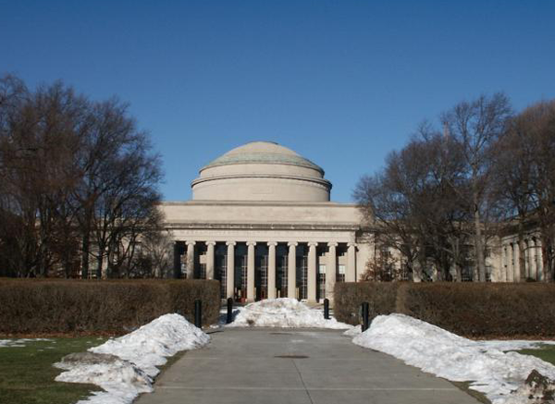
Figure 1. With Caption Below.

SECTIONS
The heading of a section should be in Helvetica 9-point bold, all in capitals (Heading 1 Style in this template file). Use Arial if Helvetica is not available. Sections should not be numbered.

Subsections
Headings of subsections should be in Helvetica 9-point bold with initial letters capitalized (Heading 2). (Note: For sub-sections and sub-subsections, a word like the or of is not capitalized unless it is the first word of the heading.)

Sub-subsections
Headings for sub-subsections should be in Helvetica 9-point italic with initial letters capitalized (Heading 3).

FIGURES/CAPTIONS AND OPTIONAL AUDIO/VIDEO
Place figures and tables at the top or bottom of the appropriate column or columns, on the same page as the relevant text (see Figure 1). A figure or table may extend across both columns to a maximum width of 17.78 cm (7 in.).
Objects | Caption – pre-2002 | Caption – 2003 and afterwards
Tables | Above | Below
Figures | Below | Below
Table 1. Table captions should be placed below the table.
Captions should be Times New Roman 9-point bold (Caption Style in this template file). They should be numbered (e.g., “Table 1” or “Figure 2”), centered and placed beneath the figure or table. Please note that the words “Figure” and “Table” should be spelled out (e.g., “Figure” rather than “Fig.”) wherever they occur.
Papers and notes may use color figures, which are included in the page limit; the figures must be usable when printed in black and white in the proceedings.

Page Numbering, Headers and Footers
Please submit your anonymous version for reviewing with page numbers centered in the footer. These must be removed in the final version of accepted papers, as page numbers, headers, and footers will be added by the conference printers.

REFERENCES
- It is recommended to have the references/citations ragged right/flush left. This way items with long string urls (web addresses) do not cause lines or entries to be letter and word spaced.
- Adobe Acrobat Reader.
http://get.adobe.com/reader/
- Anderson, R.E. Social impacts of computing: Codes of professional ethics. Social Science Computing Review 10, 2 (1992), 453-469.
- Nara To-kae, Japan, http://www.toukae.jp/tokae_e/index.html
- How to Classify Works Using ACM’s Computing Classification System.
http://www.acm.org/class/how_to_use.html.
- Klemmer, R.S., Thomsen, M., Phelps-Goodman, E., Lee, R. and Landay, J.A. Where do web sites come from? Capturing and interacting with design history. In Proc. CHI 2002, ACM Press (2002), 1-8.
- Wollscheid, A., Frankfurt, Germany, http://www.selektion.com/members/wollscheid/default.htm

BALANCE THE LAST PAGE INTO TWO AS EVEN COLUMNS AS POSSIBLE, BY NOT DELETING THIS LINE, JUST DELETE THE TEXT.

