Demonstrations Supplement
Ubiquitous Computing Conference

The Demonstration Supplement portrays the envisioned conference attendee interaction with the proposed demonstration. For example, this document may include a short usage scenario, a storyboard sketch, screenshots, illustrations, and/or photos. In addition, you are welcome to provide video documentation.

The Demonstrations Supplement also includes the various technical requirements such as preferred setting, space, power, networking, lighting, acoustical, and other special equipment. Demonstrations Supplement materials are for the purposes of review only and will not be published.

It is important to remember that the reviewers of Demonstrations submissions can only make decisions based on the knowledge contained in this document, the demonstration abstract, and the optional video. Therefore, it is through the supplement that you have the opportunity to informally describe how you envision UbiComp attendees interacting with your piece.

A full demonstrations submission consists of two Adobe Acrobat files (and an optional supporting video). The two files should be named as below with NAME replaced with the last name of the lead author. Send both files via email to khai@cs.toronto.edu

Abstract NAME_abstract.pdf
Supplement NAME_supplement.pdf

Videos are strongly encouraged for the review process, but please note that these videos will not be published or distributed at the conference. We will accept region 1 DVDs as well as NTSC VHS tapes. Those who will be sending physical versions of videos should contact the demonstration chairs prior to submission for the US postal address to use. Please note that these videos will not be returned. We will also accept URLs to digital versions of videos in Quicktime, Windows Media, AVI, and MPEG format. Please make sure the audio is clear. The reviewers are not guaranteed to watch more than eight minutes, so be concise. If there are other materials you would like to send, feel free to email us with questions.

Please send all other demonstration inquiries to demos-2006@ubicomp.org.

CONTACT INFO

First Name
Last Name
Organization
Street Address
City
State/Province
Country
Postal Code
Daytime Telephone
Email
URL

DEMONSTRATIONS DESCRIPTION
Please replace this description with your own.

Title: Title Me: A Brainstorming Process for Creating Bizarre Titles

Project Description (100 words max):

Title Me will use the FBI criminal statistics database to estimate the probability of a person at UbiComp being robbed.

Envisioned Interaction:

UbiComp attendees will see an illuminated screen inviting them to approach a large US Mailbox sized box positioned in the middle of the room. The images below show a person walking up and reading the sign atop the box. The user places their wallet/purse/moneyclip into the slot at the top of the box for analysis. A flat panel screen atop the box reports the progress of the analysis. After approximately 30 seconds the user’s belongings are returned with all cash removed along with a printout of their estimated chance of being robbed while at UbiComp. A sample of such a printout is show below.

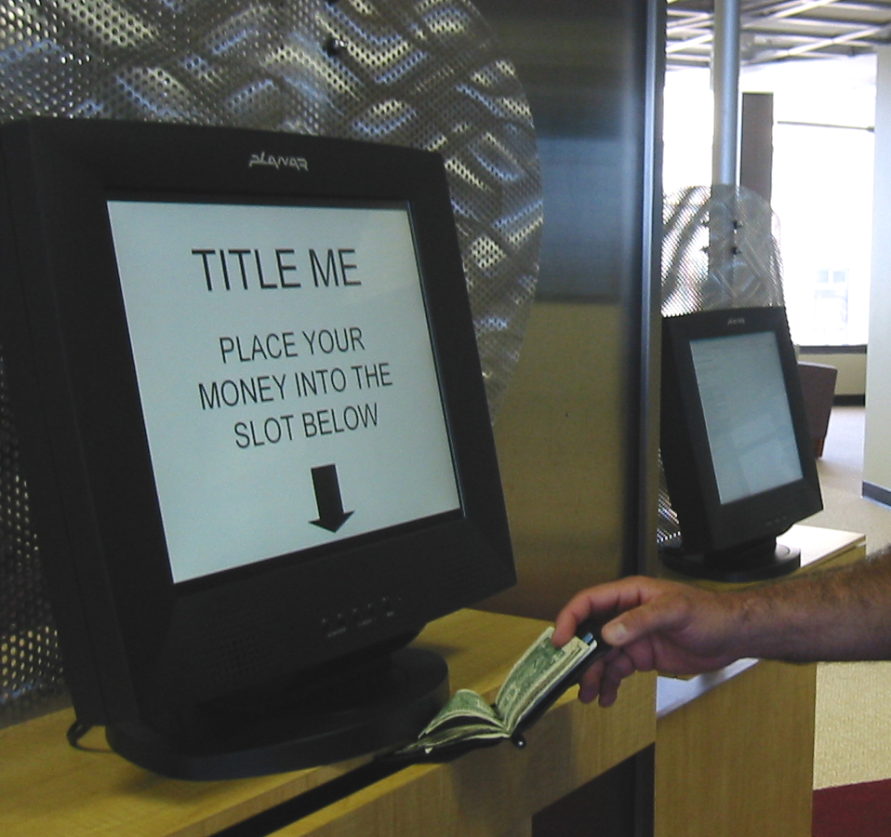 | 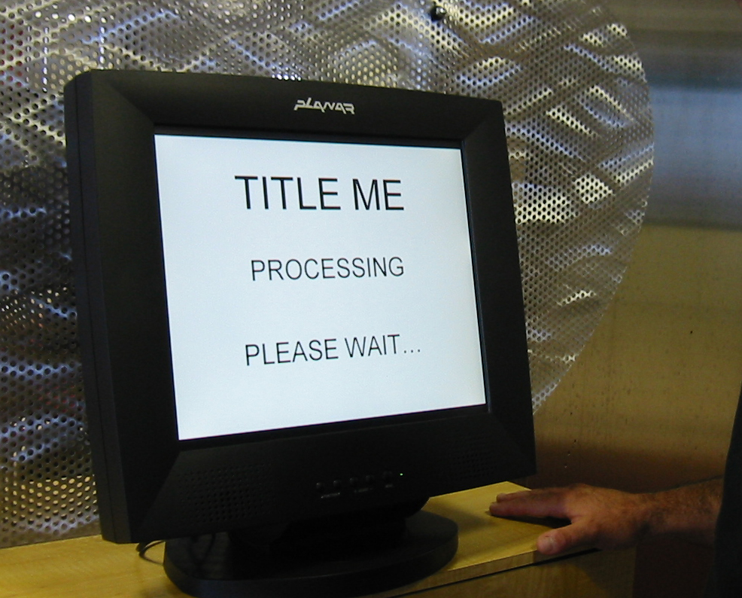
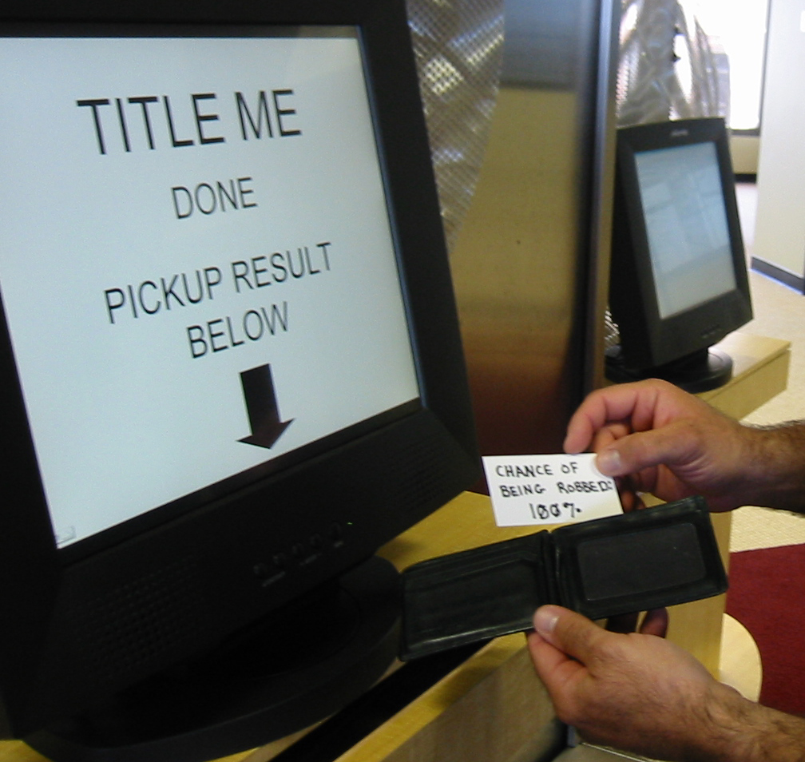 | 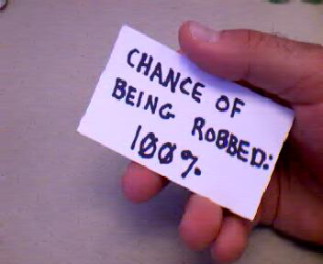

TECHNICAL REQUIREMENTS
In this section, we would like to learn about the requirements of your submission. We include several categories and questions below. These questions are examples of the types of information you might like to give us. It is not necessary to answer questions that do not apply to you. Please feel free to add additional requirement information as needed. While we can not make guarantees about what we will be able to provide, we want to work with every accepted submitter to bring their envisioned interaction to all UbiComp attendees.

Space
Example questions:
How much space will your demo require (length/height/width)?
Should it operate in two separate locations? Should it be presented against a wall? In a doorway? At a table? In a kitchen? On the ceiling? On the floor? On a tree? Etc?
Does your demo need a special table, chair, carpet, sandbox, etc.?

Acoustical
Example questions:
Are there special acoustical needs?
How much sound does your demo produce?

Lighting
Example questions:
Does the demo require special lighting?
Does it require a dark area?

Time
Example questions:
Should the demo run only at the opening demo reception or throughout the conference?
Does it work best with a single person at a time? A pair? A group?
Does the demo evolve over the course of the conference or is it self-contained within a 2 minute interaction?

Computational Equipment
Example questions:
Does the demo involve custom hardware and software or does it run on standard PC’s?
Will you be providing PC’s? How many are needed? With what specifications?
Do you need a projector? A monitor?
What other equipment is needed?
What will you be transporting?
What can UbiComp assist in providing onsite during the conference?

Networking
Example questions:
Do you need to be connected to the Internet? A database server? Wired? Wireless? Will 802.11b be used?
How many connections will you need?
What is your demonstration’s typical bandwidth usage?
Latency issues?

Radio Frequencies
Example questions:
Does your demonstration use, produce, or require any radio frequencies? Wireless cameras, microphones, Bluetooth?
What frequencies?
At what power levels?

Power
Example requirements:
My demo will require 4 circuits as follows:
- 2 20Amp drops for the two personal computers and their monitors and speakers
- 2 20Amp drops of suspended power for the overhead projectors

